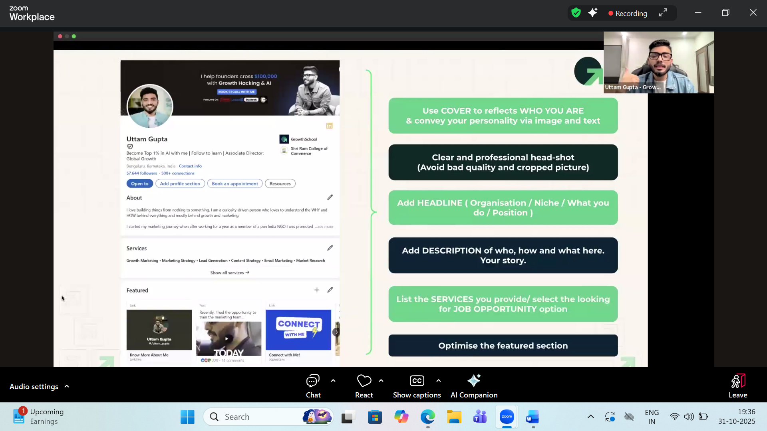

Resume worded
Engage.ai

Sales navigator

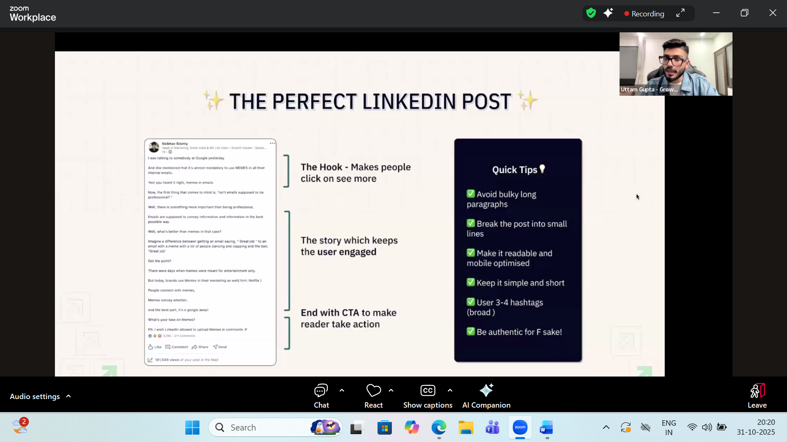

Linkedin prospect.com

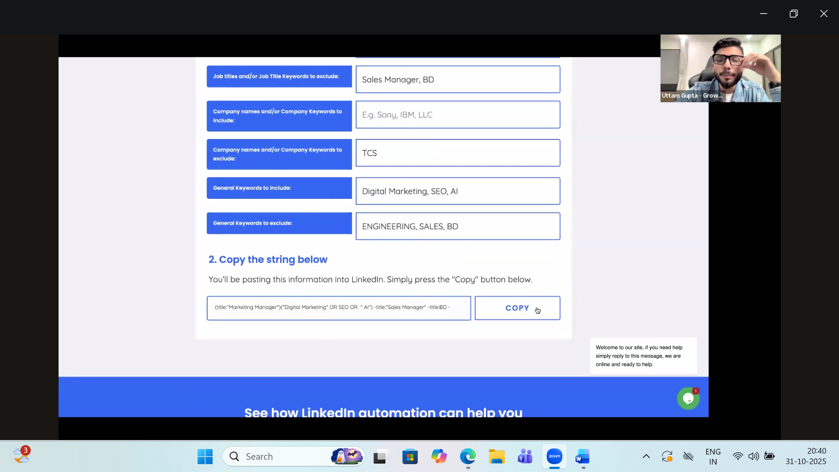

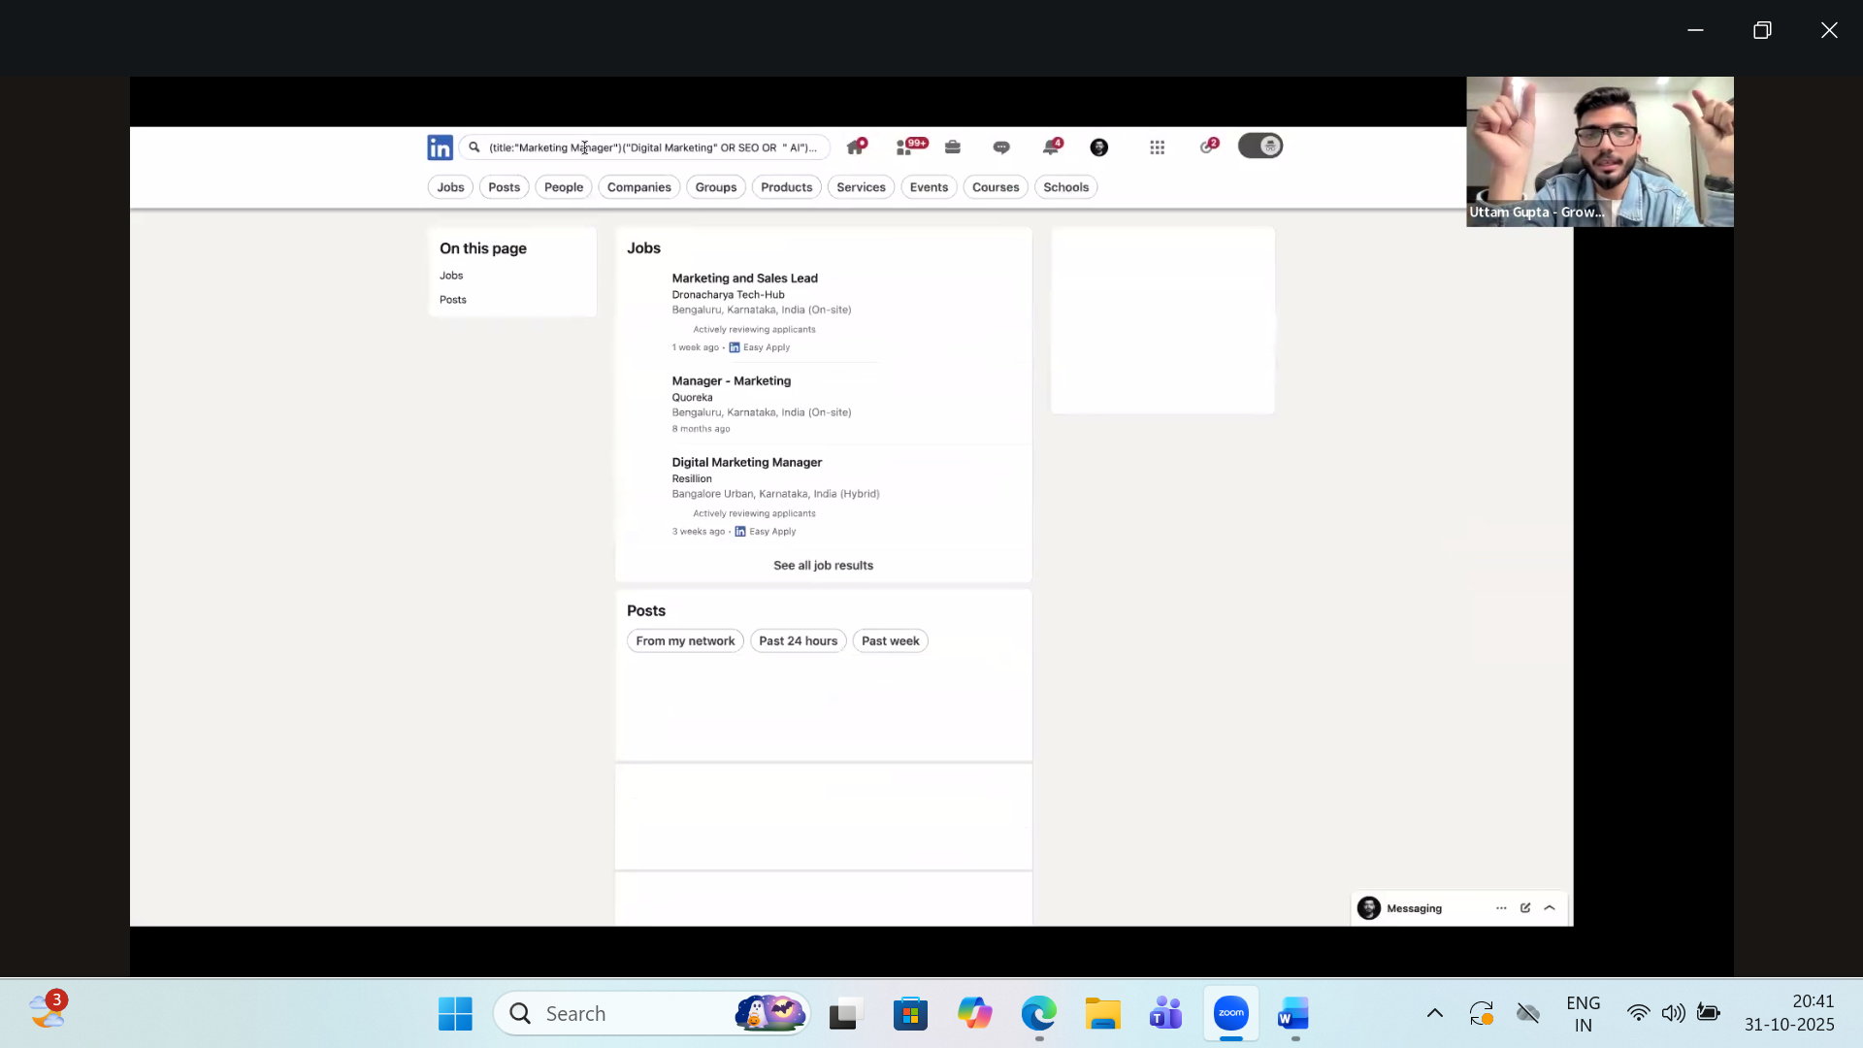

Crystal knows helping cracking better interviews

Want to know the gmail id of others from

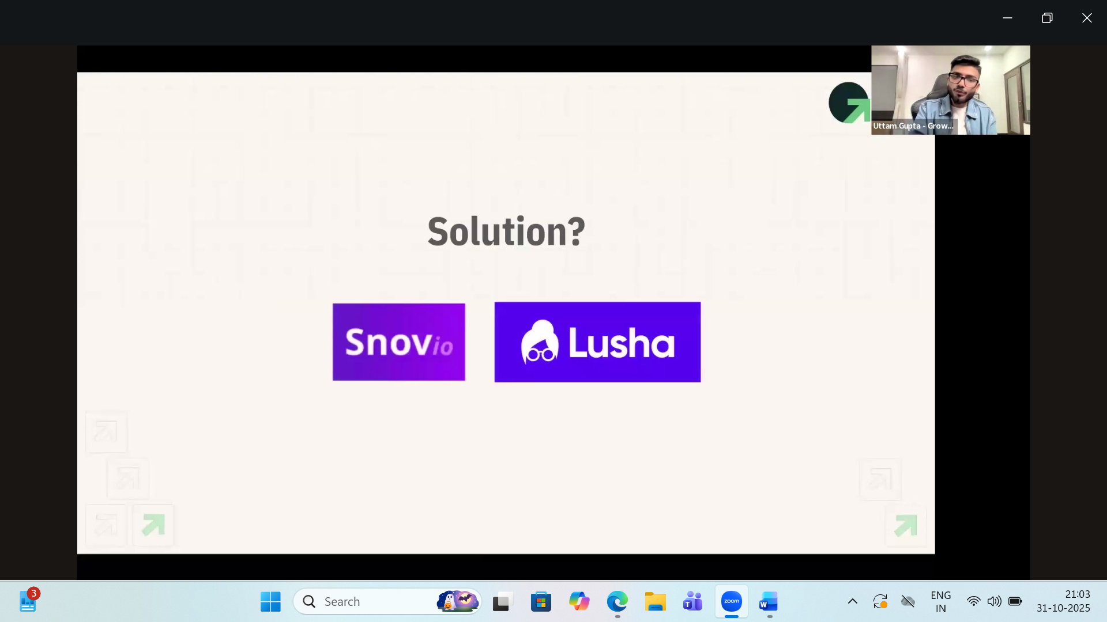

1 Target audience
2) Create LinkedIn profile
3) LinkedIn post
4) reach out to 10 people
5)

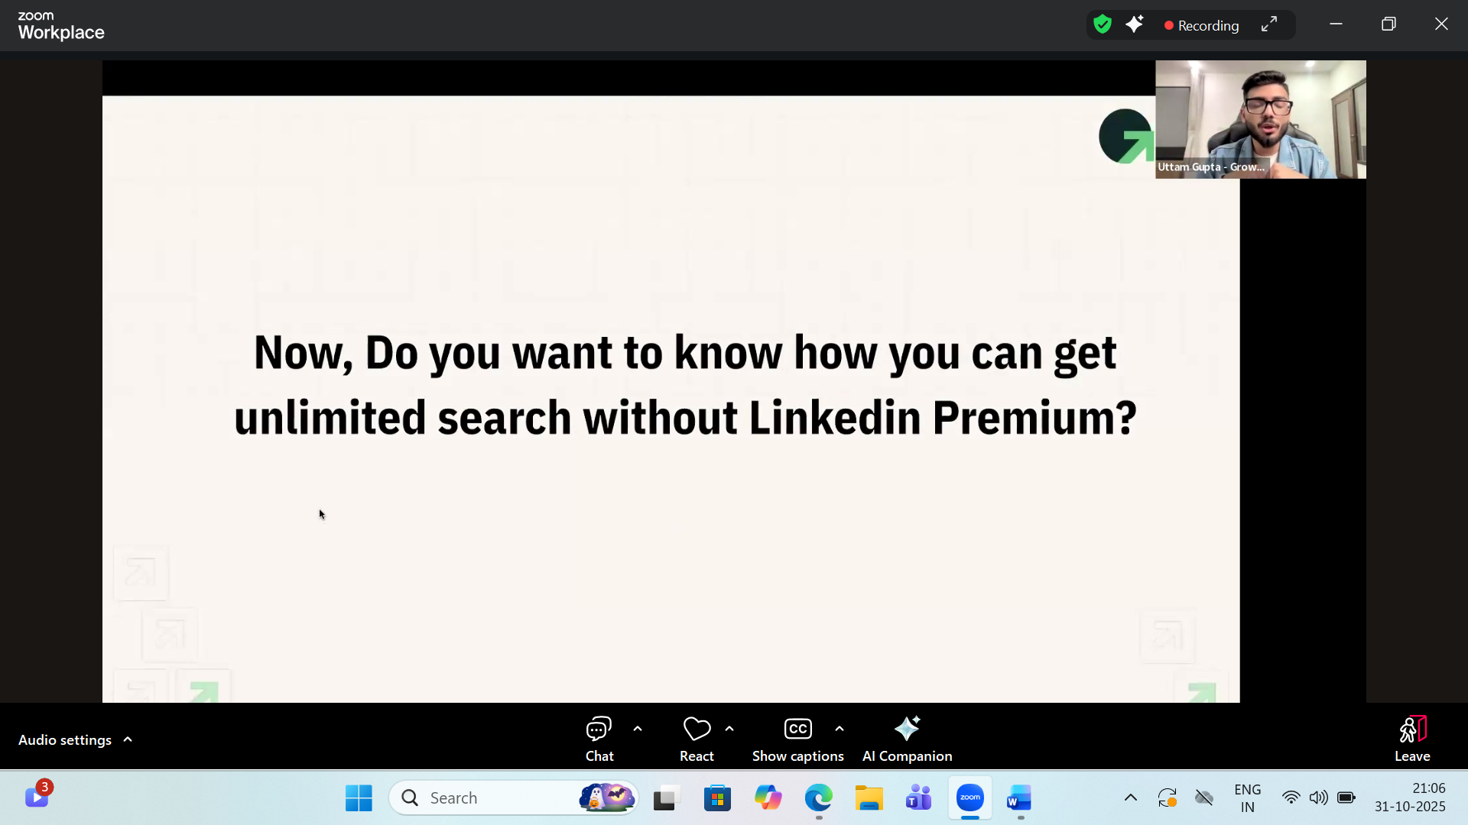

Linkedin search premiu without pay

